Course Code: AIPP
Assignment No: 10
Done by: 2503B05203 (M.Tech)
Name: B Subhash Chandra

SCHOOL OF COMPUTER SCIENCE AND ARTIFICIAL INTELLIGENCE |  |  |  |  | DEPARTMENT OF COMPUTER SCIENCE ENGINEERING
ProgramName:M. Tech |  |  |  | AssignmentType: Lab |  |  | AcademicYear:2025-2026
CourseCoordinatorName |  |  |  | Venkataramana Veeramsetty
CourseCode |  |  |  | CourseTitle |  | AI Assisted Problem Solving Using Python
Year/Sem |  |  | II/I | Regulation |  | R24
DateandDay  of Assignment |  |  | Week5 - Monday | Time(s)
Duration |  |  | 2 Hours | Applicableto  Batches
AssignmentNumber:10.1(Presentassignmentnumber)/24(Totalnumberofassignments)
 | Q.No. | Question |  |  |  |  |  | ExpectedTime  to complete
 | 1 | Lab 10 – Code Review and Quality: Using AI to Improve Code Quality and Readability  Lab Objectives  - Use AI for automated code review and quality enhancement.  - Identify and fix syntax, logical, performance, and security issues in Python code.  - Improve readability and maintainability through structured refactoring and comments.  - Apply prompt engineering for targeted improvements.  - Evaluate AI-generated suggestions against PEP 8 standards and software engineering best practices  Task Description #1 – Refactor Nested Conditionals  Task: Provide AI with the following nested conditional code and ask it to simplify and refactor for readability.  Python script.  def discount(price, category):  if category == "student":  if price > 1000:  return price * 0.9  else:  return price * 0.95  else:  if price > 2000:  return price * 0.85  else:  return price  Expected Output:  - Refactored code using cleaner logic, possibly a dictionary or separate helper functions.  Prompt:  - Refactor the given discount function to use cleaner logic, potentially employing a dictionary or separate helper functions to improve readability and maintainability. The function should apply a discount based on the price and category (e.g., "student" or other). Ensure the logic is clear, concise, and avoid repetition.  Refactored code:  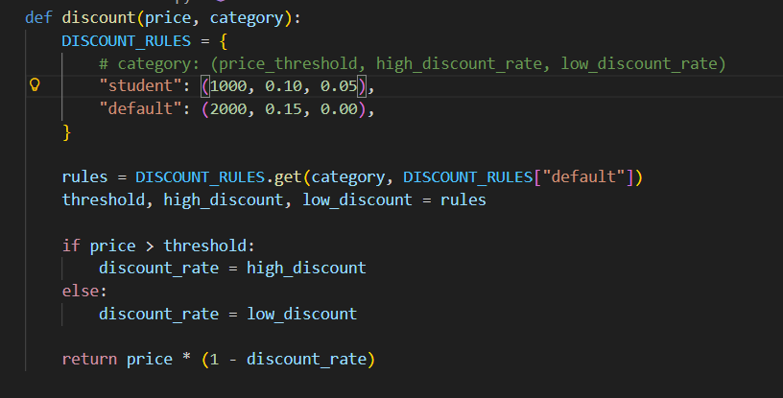  Observation:  - AI refactored the nested if-else code to more readable code by using dictionary which is easy to understand  Task Description #2 – Optimize Redundant Loops  Task: Give AI this messy loop and ask it to refactor and optimize.  Python script  def find_common(a, b):  res = []  for i in a:  for j in b:  if i == j:  res.append(i)  return res  Expected Output:  Cleaner version using Python sets (set(a) & set(b))  Prompt:  - Refactor and optimize the following messy loop to a cleaner version using Python sets. The goal is to find the common elements between two lists, a and b, by utilizing the set intersection method set(a) & set(b). Improve both readability and performance by replacing the loop with a more efficient approach using sets.  Refactored code:  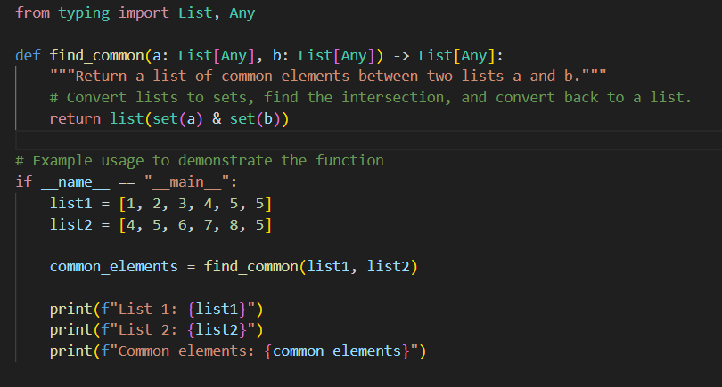  Observation:  - AI refactored the nested if-else code which checks common elements into to more readable code by using sets union  Task Description #3 – Improve Class Design  Task: Provide this class with poor readability and ask AI to improve:  - Naming conventions  - Encapsulation  - Readability & maintainability  Python Script  class emp:  def __init__(self,n,s):  self.n=n  self.s=s  def inc(self,p):  self.s=self.s+(self.s*p/100)  def pr(self):  print("emp:",self.n,"salary:",self.s)  Expected Output:  - Employee class with meaningful methods (increase_salary, display_info), formatted output, and added docstrings.  Prompt:  Improve the readability and maintainability of the following Employee class by addressing the following issues:  - Naming conventions: Rename variables and methods to follow Python's PEP 8 style guide for clarity and consistency.  - Encapsulation: Ensure proper encapsulation by making instance variables private and providing getter and setter methods where necessary.  - Readability & maintainability: Refactor code to enhance readability, reduce redundancy, and follow best practices.  - Functionality: Add meaningful methods such as increase_salary (to increase an employee's salary) and display_info (to display employee details with formatted output).  - Docstrings: Add clear docstrings for the class and methods to explain their purpose and usage.  The goal is to make the code more understandable, well-structured, and easier to maintain.  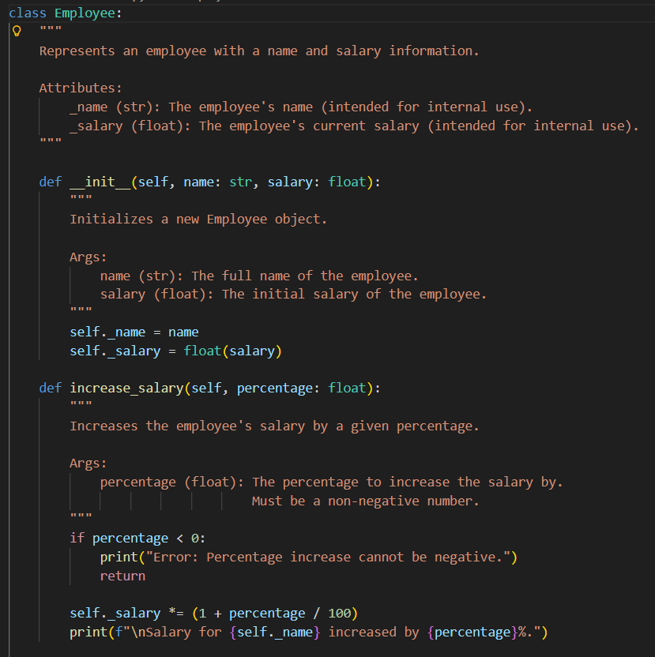  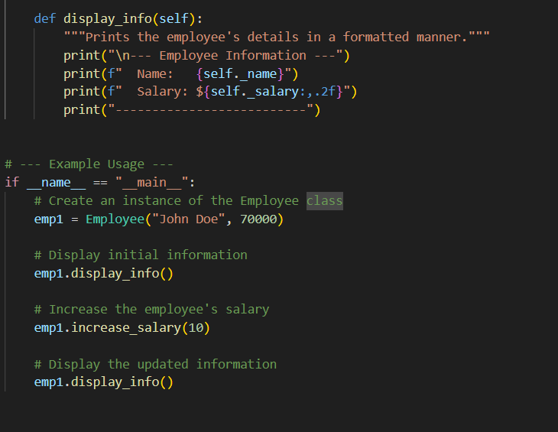  Observation:  - AI refactored the variables and functions using naming conventions and doc strings, comments which further improves readability of code.  Task Description #4 – Modularize Long Function  Task: Give AI this long unstructured function and let it modularize into smaller helper functions.  Python Script  def process_scores(scores):  total = 0  for s in scores:  total += s  avg = total / len(scores)  highest = scores[0]  for s in scores:  if s > highest:  highest = s  lowest = scores[0]  for s in scores:  if s < lowest:  lowest = s  print("Average:", avg)  print("Highest:", highest)  print("Lowest:", lowest)  Expected Output:  - Split into functions: calculate_average, find_highest, find_lowest.  - Clean main process_scores() using helper functions.  - Prompt:  Refactor the long, unstructured function by modularizing it into smaller helper functions. Split the logic into the given functions:  calculate_average(): find_highest(), find_lowest().  - Then, clean up the main function process_scores() by using these helper functions, improving its readability and maintainability.  Code:  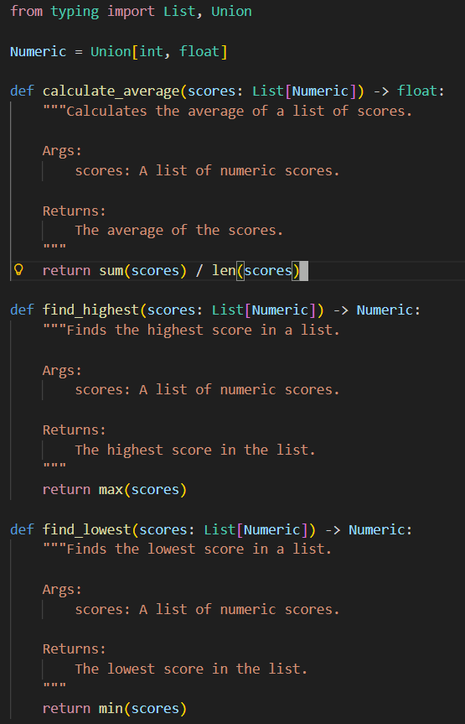  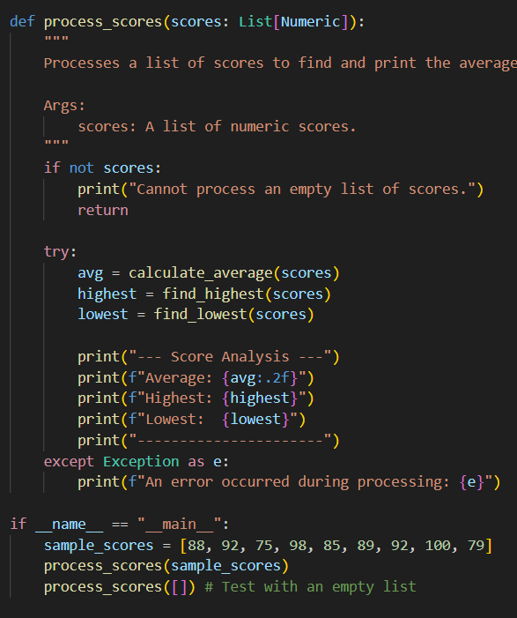  Observation:  - AI refactored the long unstructured function into small cleaner modular function for different logic along with docstrings and required comments, function call and use case example which further improves readability of code.  Task Description #5 – Code Review on Error Handling  Task: Provide AI with this faulty code and ask it to improve error handling, naming, and readability.  Python Script  def div(a,b):  return a/b  print(div(10,0))  Expected Output:  - Function with proper error handling using try-except.  - Better naming (divide_numbers).  - AI-generated docstring explaining error handling.  Prompt:  - Refactor the following faulty code by improving the following aspects:  - Error handling: Implement proper error handling using a try-except block to catch potential errors, such as division by zero or invalid input types.  - Better naming: Rename the function to divide_numbers to make its purpose clearer.  - Docstring: Add an AI-generated docstring explaining the function's purpose, parameters, and the error handling process.  - The goal is to make the code more robust, readable, and well-documented.  Code:  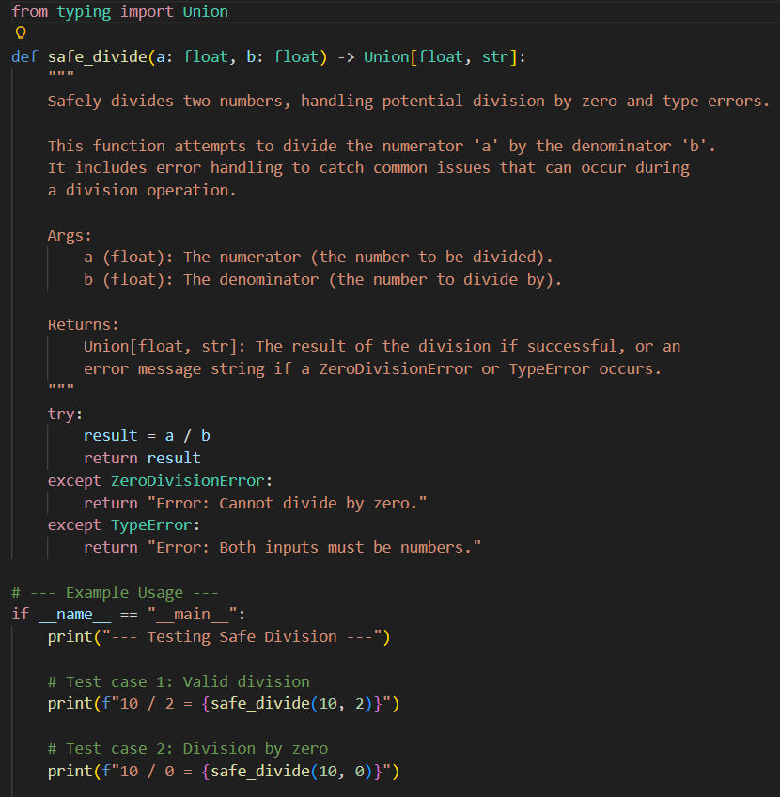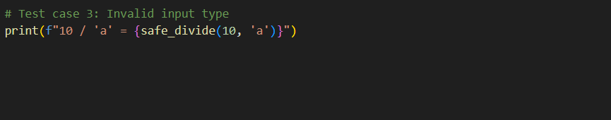  Observation:  - AI refactored the short unclear code to make proper function naming, variable types and with docstrings and required comments, function call and use case example which further improves readability of code.  Task Description #6 – Complexity Reduction  Task: Use AI to simplify overly complex logic.  Sample Input Code:  def grade(score):  if score >= 90:  return "A"  else:  if score >= 80:  return "B"  else:  if score >= 70:  return "C"  else:  if score >= 60:  return "D"  else:  return "F"  Expected Output:  - Cleaner logic using elif or dictionary mapping.  Prompt:  - Refactor the following overly complex if-else code to simplify the logic using either elif statements or dictionary mapping. The goal is to make the code more readable and maintainable by reducing unnecessary complexity and improving clarity.  Refactored code:  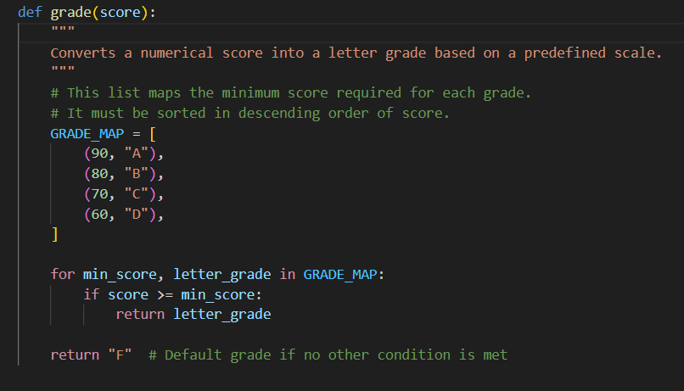  Observation:  - AI refactored the overly complex logic to more simple function using dictionary mapping and with docstrings and required comments, supporting the readability of code.  Lab Conclusion:  - AI can refactored the code either by logic, function, readability and modular functions which increase the performance |  |  |  |  |  | Week5 - Monday

